Use Case Realisation Report - Search Project Feedbacksearch project feedback
FOR
Volunteer Management System
(VMS)

CLIENT
PROJECT | Volunteer Management System (VMS)
TITLE | Use Case Realisation Report - Search Project Feedback
VERSION | 0.1a
DATE | 13-Aug-2011
 | ORIGINATOR
 | Name / Signature | Team 8S
 | APPROVAL
 | Name / Signature | Phung Kim Cuong, Dio
Institute of Systems Science |  | Document Reference
25 Heng Mui Keng Terrence  Singapore 119615 |  | VMS/PM-1.3.1/1

 | Acceptance
 | Customer Signature |  | Customer Signature
 | Name & Designation |  | Name & Designation
 | Date & Company Stamp |  | Date & Company Stamp

Revision History

Date | Version | Description | Author
12-Jun-2011 | 0.1a | Creation | Team 8S
11-Aug-2011 | 0.2a | Updated | Team 8S
 |  | Refer to amendment history

Table of Contents

1. Brief Description 3
2. Flow of Events 3
2.1 Standard Flow 3
2.2 Exceptions 3
3. Interaction Diagrams 3
3.1 Domain Collaboration Diagram: Post Feedback 3
4. Participating Objects 4
5. Derived Requirements 4
6. Derived Requirements 4
ANNEX D Amendment History 4

Use Case Realisation Report - Search Project FeedbackSearch Project Feedback

Brief Description
The use case enables registered user with project manager role to search/view the project feedback.

Flow of Events
The standard flow of events for this use case and any exceptions are described in the following subsections. See section 3.1for an overview of the participating Actors and Domain Objects.

Standard Flow

Precondition: Project Manager has logged in the system and use case 4.6 has been executed

This use case provides the user interface related functionality that will be provided to the User, as follows:
- The use case starts when the project manager selects the Search Project Feedback option from the MenuScreen user interface. The MenuScreen.selectSearchProjectFeedback() method is triggered.
- The MenuScreen.selectSearchProjectFeedback() triggers the MainController.searchProjectFeedback() operation which delegates to ProjectFeedbackSearchScreen.diplayScreen().
- The displayScreen() launches the user interface ProjectFeedbackSearchScreen.
- The project manager uses the ProjectFeedbackSearchScreen user interface to select or key in the project feedback criteria like the project name. When the project manager clicks the Search button in the form, ProjectFeedbackSearchScreen.enterSearchCriteria() is called.
- The enterSearchCriteria() will triggers the ProjectFeedbackController.processSearch() to retrieve the list of the project feedback that match the criteria.
- The ProjectFeedbackController.processSearch() will triggers the ProjectFeedback.findProjectFeedbackByProject() operation to retrieve the list of the project feedback that match the criteria.
- After that, ProjectFeedbackController triggers the ProjectFeedbackSearchScreen.displayResult() operation to display the list of the matching project feedback.
- The ProjectFeedbackSearchScreen.displayResult() operation will also triggers the ProjectFeedback.getProjectFeedback() operation to retrieves the project feedback records.
- The use case terminates when the project manager click the Close button of the ProjectFeedbackSearchScreen.

.

Exceptions
The following exceptions have been identified:

- There is no matching project feedback: if there is no matching Project Feedback for the selected project, the ProjectFeedbackController will return empty list of Project Feedback passing in the displayResult() and the ProjectFeedbackSearchScreen will show an empty list with the “No project feedback found” message.

Interaction Diagrams

Collaboration Diagram for Search Project Feedback

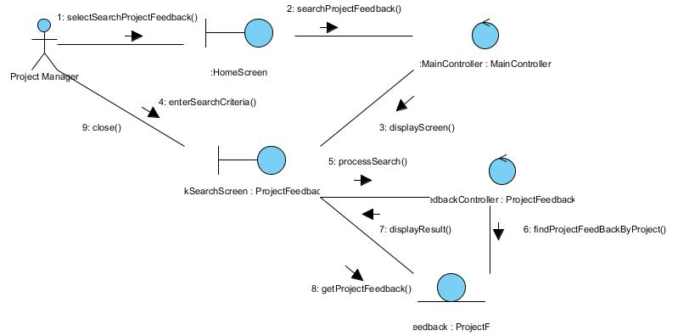

Participating Objects

HomeScreen
This boundary object is used for redirecting and displaying of home screen details and menu. All the user actors use this object.

MainController
This control object co-ordinates the menu selection and dispatches of requests of the volunteer management system. It delegates the user requests to the specific use case control objects for carrying out the use cases.

FeedbackController
This control object co-ordinates the ProjectFeedback information update, creation and retrieval.

ProjectFeedback
This entity object stores the details concerning a project feedback.

ProjectFeedbackSearchScreen
This boundary object is used to display project feedback info and allow user to search the project feedback.

Class Diagram
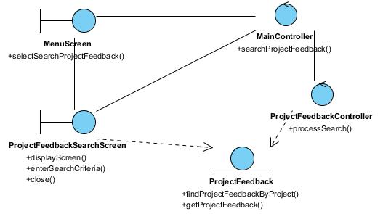

Derived Requirements
This project manager’s PC keyboard or mouse will be used to select required criteria and view all the system responses.

ANNEX D Amendment History

This is a record of all amendments made to the Document.
Version | Chapter / Section | Page No | Notes of Amendments or Changes

